Guide to Self-Identification for CUNY Employees

For instructions on completing the self-identification, see Page 3. Sample screen prints are shown on Page 4, and CUNY’s Policy on Non-Discrimination is provided on Page 6.

If you have difficulty completing the self-identification, or need assistance due to a disability, contact your campus Human Resources Office.
What is self-identification? | CUNY periodically surveys faculty and staff for data on gender, race, ethnicity, veteran, and disability status to comply with federal, state and local equal employment regulations.  We use summary data to prepare Affirmative Action and diversity plans, to create statistics, and to respond to requests from government, legislative or regulatory groups. CUNY is obligated to limit the distribution of this information to these purposes.  Self-identification is voluntary. However, nearly all CUNY employees have provided self-identification data and we hope you will participate.  Your individual information is confidential and is only available to specifically authorized individuals for creating required reports and analyses. Your supervisor will not see this information and it will not be used in association with any employment decision.
Selecting Ethnicity Choices | The Ethnicity section has three questions.  Question 1: “Are you Hispanic or Latino?”  According to current federal regulations, if you select “Yes,” Hispanic/Latino is recorded as your ethnicity for reporting purposes.  Question 2: “What is your Race or Ethnicity?” Select any that apply.  - Selecting Puerto Rican is recorded as both Hispanic/Latino and Puerto Rican.  - Selecting Italian American is also recorded as White. You may identify other ethnicities in addition to White/Italian American.  CUNY’s Chancellor designated Italian Americans as a protected group at CUNY in 1976. We collect this data for required reporting. CUNY requests data on Puerto Rican status in response to many requests for this information over the past thirty years.  Question 3: “What is your Ancestry or Ethnicity”? While not a federal requirement, we urge you to consider completing this section. You may enter as many of the choices in the drop-down menu as you wish.
The “Ancestry or Ethnicity” section | As a public employer in one of the most diverse cities in the world, CUNY receives requests for statistics on the diverse ancestries of our employee population. CUNYfirst ancestry choices use generally accepted, current names of geographic regions and countries. You do not have to be born in a specific region to consider it part of your ancestry. As with other questions, this section is voluntary.
Gender Identity | CUNY provides the following gender identification choices: Female, Male, Transgender, Gender Non-Conforming, Non-Binary, Other Gender Not Listed, and Unspecified (you do not wish to respond).  While you can change your gender identification in CUNYfirst at any time, there is a separate process to change your name or indicate a preferred name. Your Human Resources department can advise you on the process and required documentation.
Disability Status | CUNY prepares annual Affirmative Action Plans for Veterans and Individuals with Disabilities. This reflects a nationwide effort to create welcoming and inclusive workplaces.  Anyone’s disability status may change over their lifetime. We urge you to review and update your selection. You may also indicate that you do not wish to provide this information.  Completing the self-identification does not automatically create a request for a disability accommodation. You may request an accommodation in order to perform the essential functions of your job according to CUNY’s Policy on Reasonable Accommodations and Academic Adjustments: http://www2.cuny.edu/about/administration/offices/legal-affairs/policies-procedures/reasonable-accommodations-and-academic-adjustments/
Veteran Status | CUNY prepares annual Affirmative Action Plans for Veterans and Individuals with Disabilities. This reflects a nationwide effort to create welcoming and inclusive workplaces.  Veterans should self-identify even if they are not currently eligible for, or receiving, government Veterans’ benefits.  Protected Veterans may have access to additional employment benefits such as additional points on a Civil Service examination score. Veterans should contact the Human Resources department on their campus for information.
Completing the Self-Identification | Sample screen prints are provided at the end of this document.  - Sign on to CUNYfirst.  - Choose “Employee Self-Service” from the CUNYfirst Home Page by clicking on the name “CUNYfirst Home” and selecting from the drop-down menu. (See Diagram 1)  - Select the tile called, “Personal Details”. (See Diagram 2)  - Visit the following pages for detailed information and instructions. Note that some screens will require you to click an “update” button, and others may require you to click on an arrow on the right-hand side of the row. (See Diagram 3)  - Ethnic Groups (Ethnicity and Ancestry)  - Disability  - Veteran Status  - Gender Identity  - Be sure to “Update”, “Save” and/or “Submit” as instructed on each screen.  - You can also update your CUNY Alert preferences, email addresses, telephone numbers, and emergency contact information from the Self-Service menu.

Sample Screen Prints for Self-Identification

Note: CUNYfirst menu choices may vary depending on your job assignment.
Diagram 1: CUNYfirst Home Page
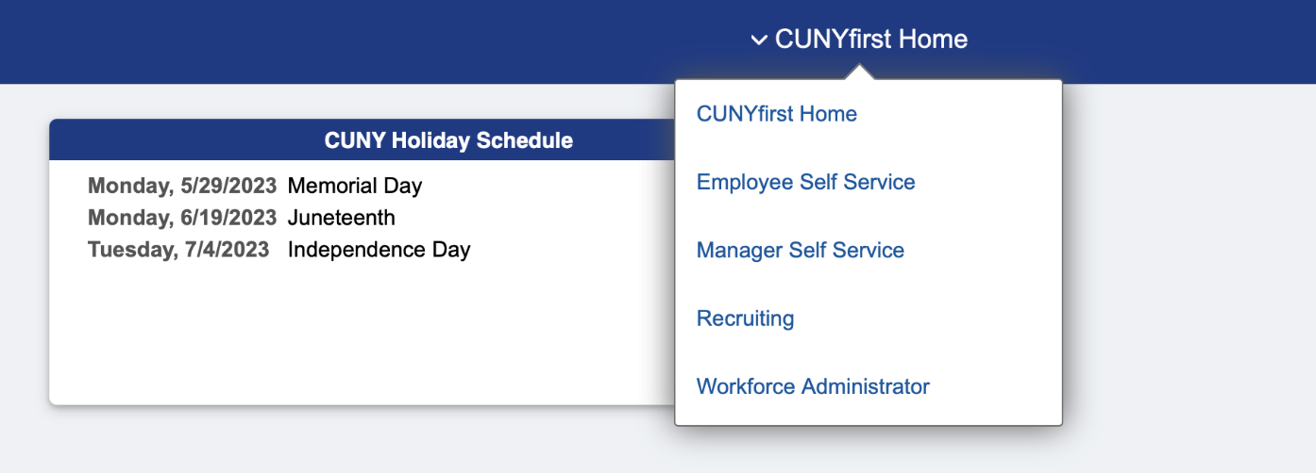
Diagram 2: CUNYfirst Self-Service Menu
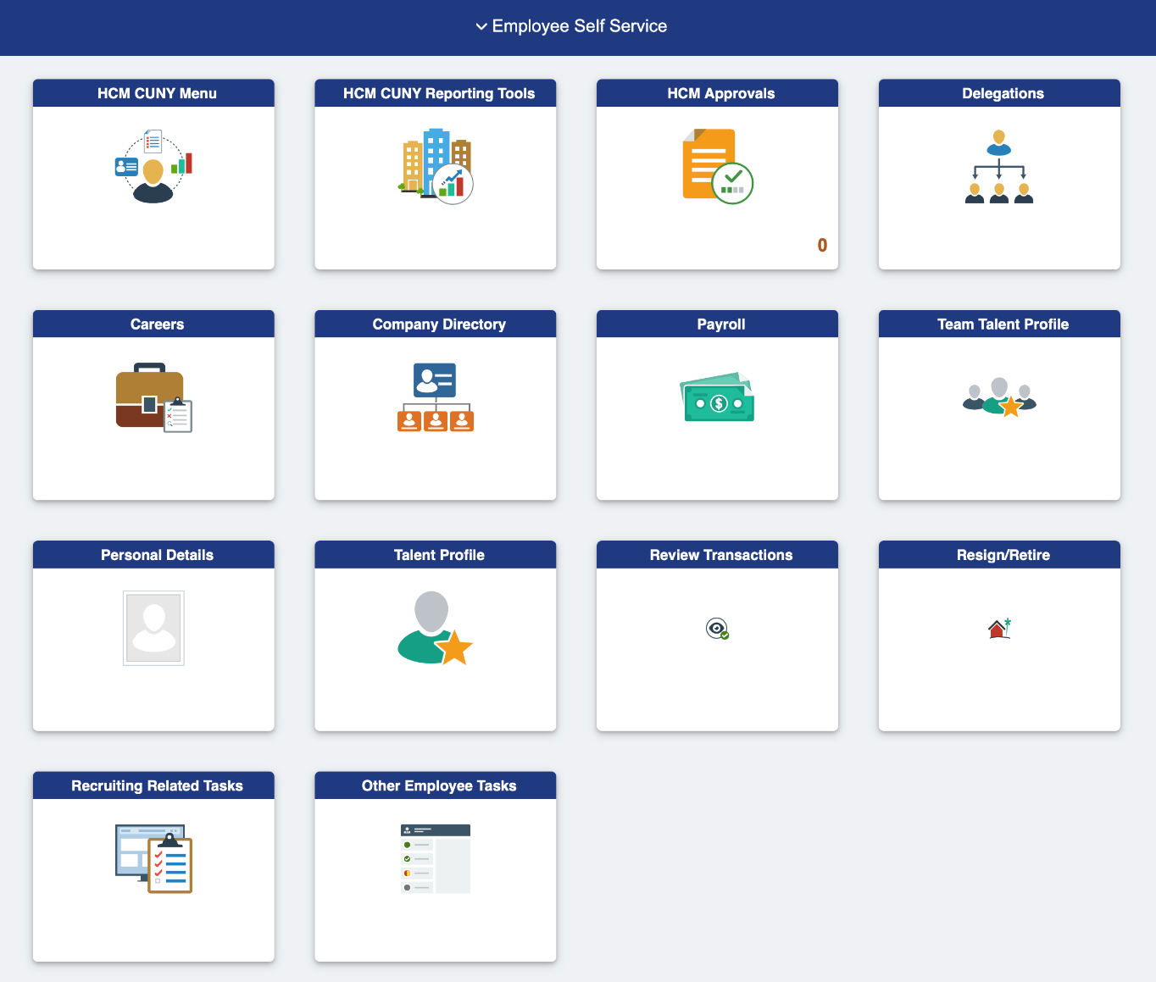
Diagram 3: Personal Details Menu
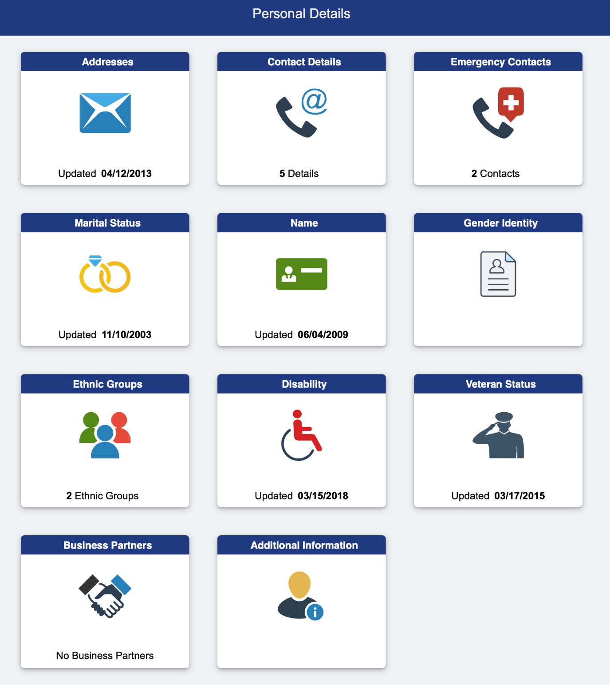
Policy on Equal Opportunity and Non-Discrimination

The City University of New York (“University” or “CUNY”), located in a historically diverse municipality, is committed to a policy of equal employment and equal access in its educational programs and activities. Diversity, inclusion, and an environment free from discrimination are central to the mission of the University.

It is the policy of the University—applicable to all colleges and units— to recruit, employ, retain, promote, and provide benefits to employees (including paid and unpaid interns) and to admit and provide services for students without regard to race, color, creed, national origin, ethnicity, ancestry, religion, age, sex (including pregnancy, childbirth and related conditions), sexual orientation, gender, gender identity, marital status, partnership status, disability, genetic information, alienage, citizenship, military or veteran status, status as a victim of domestic violence/stalking/sex offenses, unemployment status, or any other legally prohibited basis in accordance with federal, state and city laws.

It is also the University’s policy to provide reasonable accommodations when appropriate to individuals with disabilities, individuals observing religious practices, employees who have pregnancy or childbirth-related medical conditions, or employees who are victims of domestic violence/stalking/sex offenses.

This Policy also prohibits retaliation for reporting or opposing discrimination, or cooperating with an investigation of a discrimination complaint.

CUNY Office of Recruitment and Diversity, March 2025 ord@cuny.edu

