Michelle Niehues
Video Bio: https://balancinglifesissues.sharepoint.com/:v:/s/BLITeam/IQBbeFLvi9j5SIr9BM6cKzDEAYri-SUgseXGFEfQtq37X0M?e=o3dBph
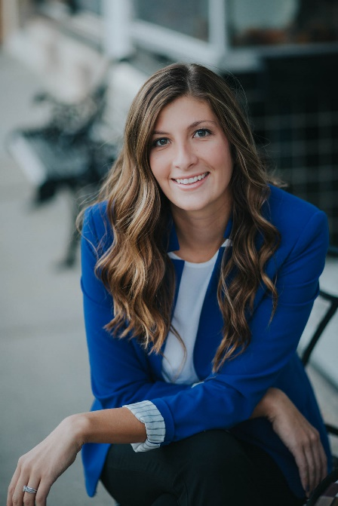
Michelle Niehues is a Licensed Clinical Marriage and Family Therapist. She has 9 years of experience offering counseling services. She is passionate about helping clients thrive in all facets of their life while staying rooted in their values. Michelle has extensively researched factors which contribute to quality of life in both our personal and work lives. She is trained in systemic theories which emphasize understanding our challenges are often multi-faceted. She believes in empowering both individuals and employers to strive for healthy communication, pursuit of values and mission, and productivity.
Being a family therapist has been a lifelong passion of hers, and it is for that reason she has a natural understanding of behaviors, feelings, and interactions. She currently provides individual and couples counseling services with New Leaf Counseling. She also provides trainings, public speaking events, and coaching services. She has previous clinical experience at a domestic violence shelter as well as with children diagnosed with various neurological disorders. She received a Bachelor of Science in Family Studies and Human Services with a Minor in American Ethnic Studies through Kansas State University. She pursued higher education in North Carolina through Pfeiffer University, and obtained her Master of Science in Marriage and Family Therapy through Friends University.
In her clinical work, Michelle Niehues has walked with both individuals and couples in their journey's of infertility and loss of a child. She has received extensive continuing education on perinatal and postpartum care. This includes understanding the impacts on mentional, emotional, and physical health of navigating miscarriages and stillbirths. As well as understanding up-to-date research and knowledge on challenges with infertility, options available, and the challenges both physically and emotionally couples face when trying to conceive. She sits with clients in the challenges of grief and works to create a safe place for conversation and emotional processing.

